**Create and Configure IBM services IOT Watson Platform**

**Project Title**: Smart Solutions for Railways

**Team ID**: PNT2022TMID25665

**Step1**: Log in your registered id

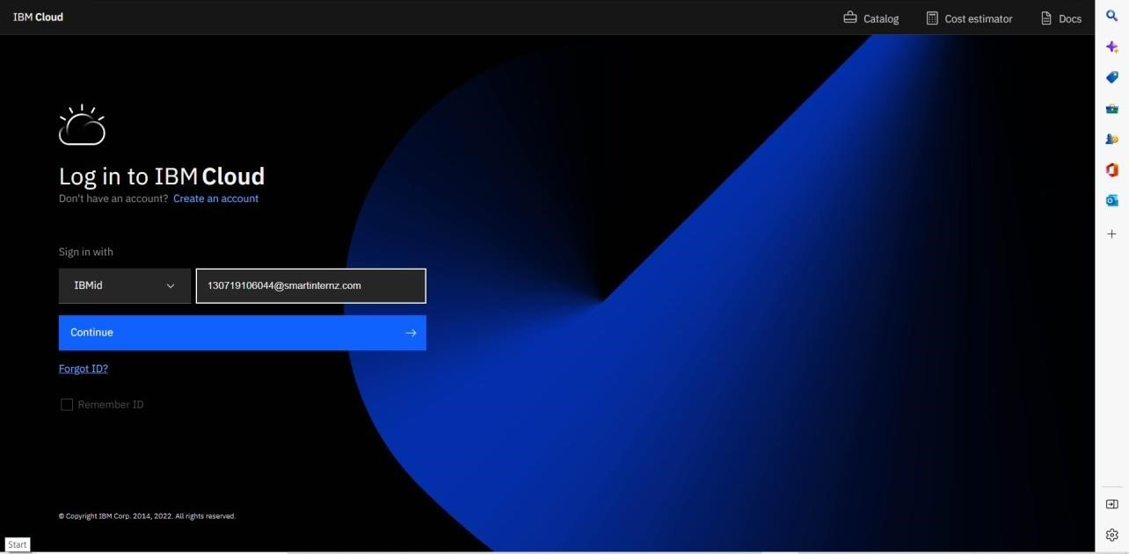

**Step 2:** Click Catalog where you find the services and internet of thing you can select and make location as Frankfurt.

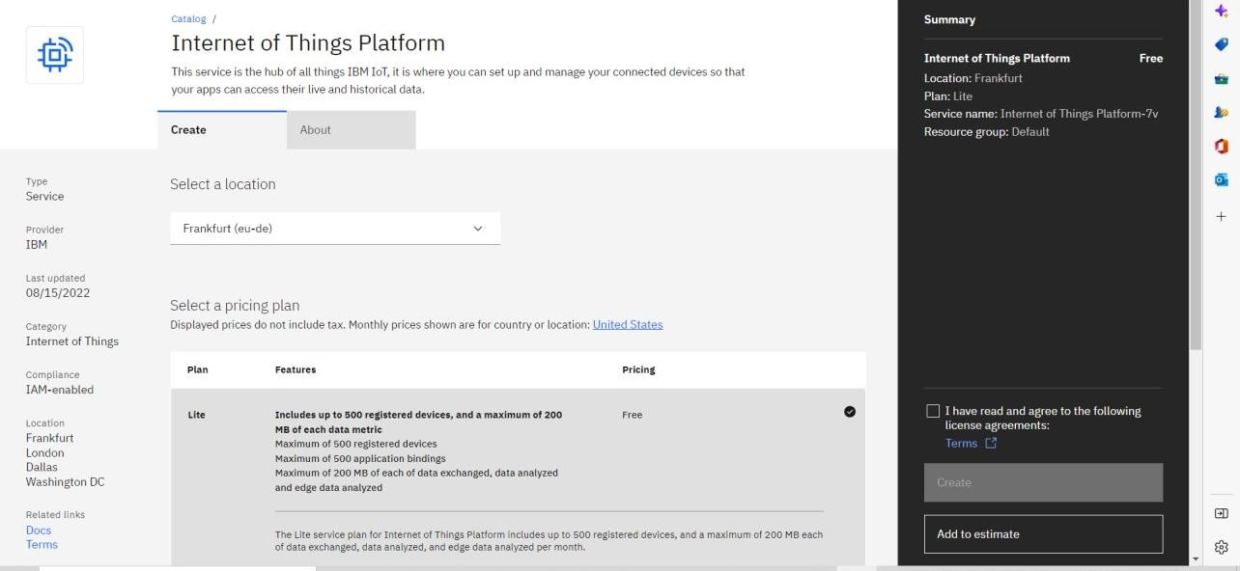

**Step 3:** click create and the launch tab get open, then click launch

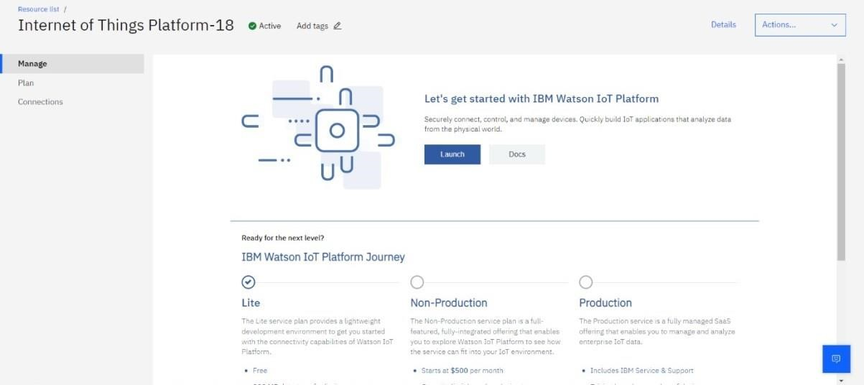

**Step 4**: It redirect you to IBM WATSON platform where you need to click sign in and login IBM.

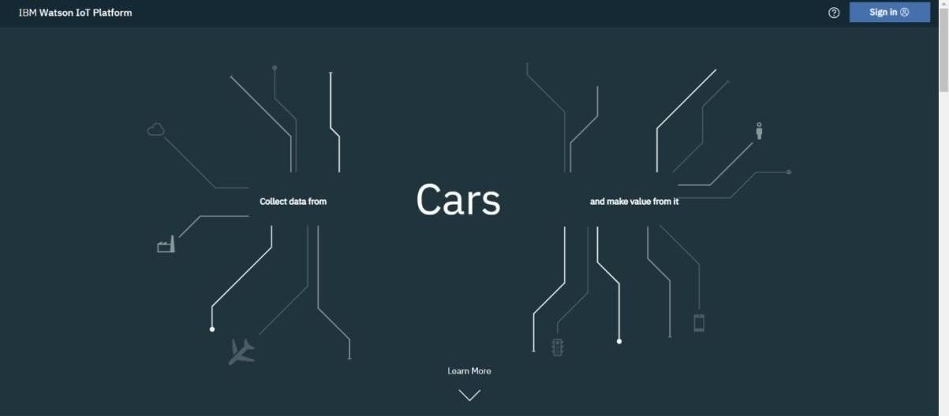

.

**Step 5:** where you find this tab which is used to add device, app, member, usage, security can be worked

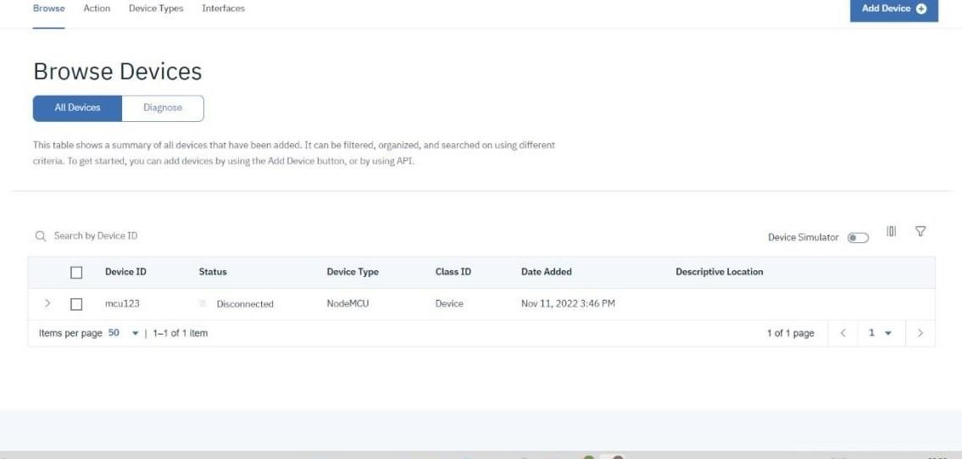

**Step 6:** check boards for risk and security overview card, it uses for graphical representation boards.

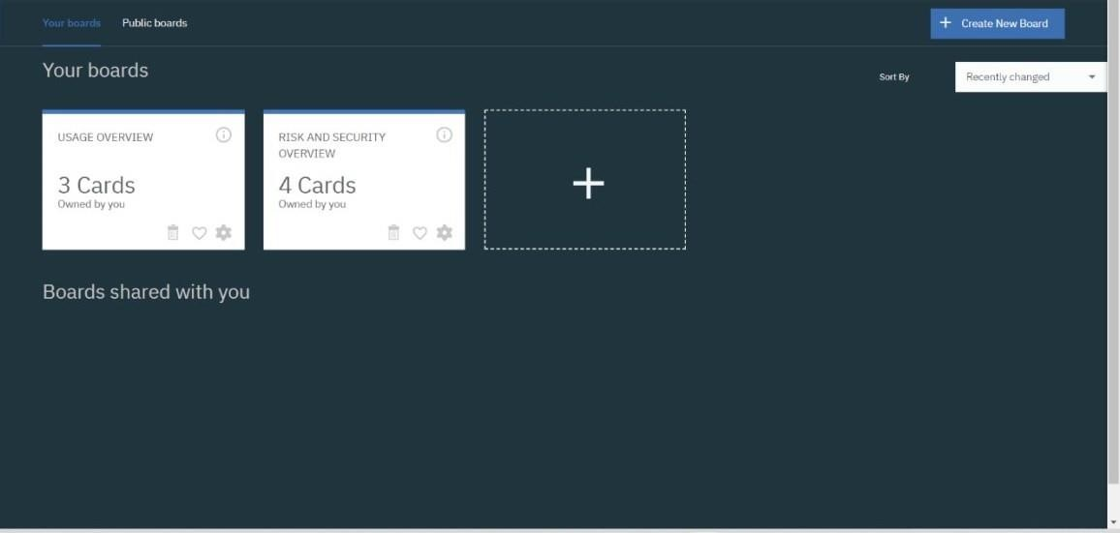

**Step 7:** after clicking create a new device / add device you can choose a device type and device id and complete the following information to create a device.

